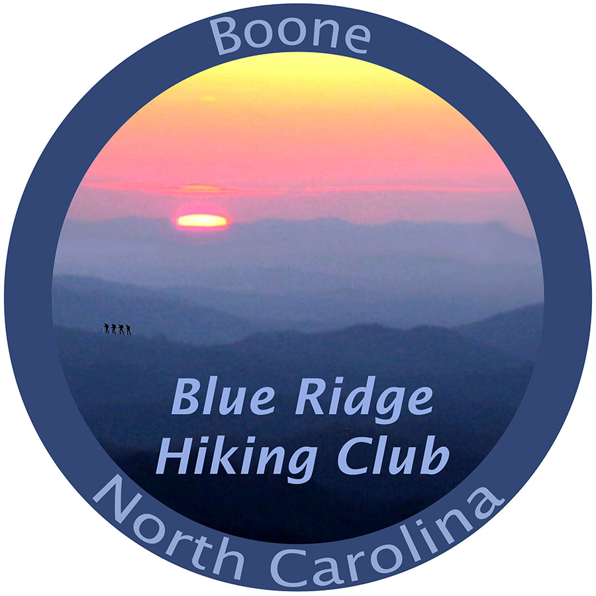

**Monday Hike List for 4thQTR 2024**

**All Monday hikes meet at 9:30 am, are 5 miles or less in length, offer a relaxed pace and are done by noon, mostly. No dogs please. Children and grandchildren, guests, visitors, and nonmembers are very welcome.**

**OCTOBER**

**Oct 7: Trout Lake to Manor House & Figure 8 Trail: Meet at Trout Lake parking lot (1st exit left off Parkway just south of Cone Manor going to Rt. 221 and then take an immediate right, nearly a U turn, onto Shull's Mill Rd going under parkway), and an immediate angling right onto single lane paved access to parking around the lake.**

**Oct 14: The Maze and Apple Barn at Cone Manor. Meet at Bass Lake lower parking area, off Rt. 221 just south of Blowing Rock.**

**Oct 21: Mountain-to-Sea Trail: Meet at the Raven Rock Overlook, hiking south toward Thunder Hill and return. BRP MP 289.5.**

**Oct 28: Flat Top Observation Tower + Cone Memorial. Meet in front of the Carriage House by Cone Manor, BRP MP 294.1.**

**NOVEMBER**

**Nov 4: Tanawha Trail to Holloway Mountain Road, and on to an older community cemetery. Meet at boat ramp parking at Price Lake, BRP MP 297.**

**Nov 11: Trout Lake to Rich Mountain. Meet in parking area of Trout Lake off Shull's Mill Road near BRP Milepost 294.6.**

**Nov 18: Price Lake plus. Meet at Boat ramp parking area, BRP MP 297. Since this is a short hike, be prepared to hike over to and up a bit of the Tanawha Trail.**

**Aug 19: Green Knob Trail: This is a short trail with a bit of a climb. Meet at Sims Pond Overlook, BRP MP 295.9.**

**Nov 25: Bass Lake to Cone Manor Loop. Meet at Bass Lake lower parking area off 221 just south of Blowing Rock.**

**DECEMBER**

**Dec 2: Old John’s River Road to Boone Fork and the new MST bridge. Meet at Price Picnic area. BRP MP296.4.**

**Dec 9: Bass Lake to Apple Barn & return. Meet at Bass Lake lower parking area off 221 just south of Blowing Rock.**

**Dec 16: Carriage Barn to Blowing Rock Stables. Meet at Cone Manor House in front of the Carriage Barn BRP Milepost 294.1.**

**Dec 23: Old John’s River Road to Price Lake, and perhaps a visit to King's marker. Meet at Sim’s Pond Overlook, BRP MP 295.9.**

**Dec 30: Trout Lake to Rich Mountain + The Maze. Meet in parking area of Trout Lake off Shull's Mill Road near BRP Milepost 294.6.**

**Wednesday Hikes 4th Quarter 2924**

**OCTOBER**

2 - **Virginia Creeper Bike Ride** - Bill Baker.  Contact and more info forthcoming. [williamr.baker@prodigy.net](mailto:williamr.baker@prodigy.net), 828-295-8677

9 - **Tanawha: Rough Ridge from Boulder Fields:** Parking BRP mile 302.1. Up and back.  2 miles gentle uphill with steeper final climb to top of Rough Ridge. Roots and Rocks. Moderate. 4.5 miles 500-600 elevation gain.   Bring sticks, water and snack for lunch on top.  No Dogs.   Email [juinadams@yahoo.com](mailto:juinadams@yahoo.com) or call 828-295-9607 (landline-no texts) for meeting time, place and carpooling opportunities.

 16 - **Babel Tower to Linville Gorge.**  We'll meet at 9am to carpool from Linville Land Harbor (we'll leave by 9:15M). High clearance vehicles (SUVs, trucks) recommended for the drive to the trailhead.  We'll hike to Babel Tower to see the gorgeous view of Linville Gorge, then down to the Linville River where we'll have a snack while sitting amongst the rocks and falls. We will be here for an extended period of time to enjoy the views. Then we'll have a gradual elevation gain back to the vehicles. This hike is 3-3.5 miles with 1400 ft. of elevation gain and is rated difficult. Hiking poles are recommended. Please bring lunch or a heavy snack, water, electrolytes, sunglasses, and a hat. No dogs. Text hike leader Kelly McDuffie at 813-787-1198.

Link to the meeting point:

[https://maps.app.goo.gl/KpW4rZnv2Ms1EYM9A](https://www.google.com/url?q=https://maps.app.goo.gl/KpW4rZnv2Ms1EYM9A&sa=D&source=calendar&usd=2&usg=AOvVaw1J8ay7CYuyqBZQPO_mNV47)

23 - **Carver’s Gap to Grassy Ridge**

Hike is 6 mi., approx. 4 hours, rated moderate to strenuous. Spectacular 360 views along part of the AT that crosses the Balds. Trail is rocky with steep slopes in each direction, reaching 6,000 ft. elevations. Hiking stick(s) recommended. Bring water and lunch. No Dogs. Covid/Respiratory illness precautions. Contact Cyndi for meeting location, time and carpool options. [Plantseeds3@gmail.com](mailto:Plantseeds3@gmail.com)

30 - **Hawksbill and Spence Ridge trail to Linville River**: We will start with Hawksbill and spectacular views of the gorge. Moderate. 1.8 mi, 670 ft. elev. gain.  Then we drive to the Spence Ridge trail which is the first one on the right beyond the Hawksbill trailhead.  The trail descends to the Linville River near the foundations of the old footbridge which washed away many years ago.  There are beautiful views of rocks and streams on the way down, as well a great site for lunch and exploration by the river. Possibility of some fall colors near the bottom. 3 mi. round trip, 915 ft. elev. moderately strenuous.  Bring water and lunch.  No Dogs.   Email [juinadams@yahoo.com](mailto:juinadams@yahoo.com) or call 828-295-9607 (landline-no texts) for meeting time, place and carpooling opportunities.

**NOVEMBER**

6 - **OverMountain Victory trail to Brichfield trail,** 5 miles, moderate. Hike through ~ 8 pastures with fantastic views then return via Lovely Birchfield trail running along the creek. Carol Ann Mitchell Hike Leader 423-772-4280, text iffy 423-957-1207, email [camitchell21@gmail.com](mailto:camitchell21@gmail.com). No dogs, Covid precautions.

13 - **Elk Knob Back Country Campsite Trails**Downhill and back, ridge view at bottom, waterfall/cascade along the way.  No rock climbing, several small water crossings, fairly steep.  Bring water, snack and sticks.  6+ miles.  Moderate to strenuous.  No Dogs.  Email [juinadams@yahoo.com](mailto:juinadams@yahoo.com) or call 828-295-9607 (landline-no texts) for meeting time, place and carpooling opportunities.

20 - **Mt Jefferson, Ashe Count,** is a forest  hike from the ranger station to the official summit and Luther Rock with splendid views and returning to the start. Distance 6-7 miles. We will stop several time for the views. Dress for the weather and using hiking sticks is to your advantage. No dogs, Hiking  leader Allmuth Perzel 336-982-8591

27 - Philip Kagan, TBD, text 828-386-8205 or email [pskagan@gmail.com](mailto:pskagan@gmail.com).

**DECEMBER**

4 - **Boone Fork Trail**5 miles, moderate, going through campground then brief open field into the woods, finishing along the water and through large open field. Carol Ann Mitchell Hike Leader 423-772-4280, text iffy 423-957-1207, email [camitchell21@gmail.com](mailto:camitchell21@gmail.com). No dogs, Covid precautions.

11 - **Linville Falls** - The hike will begin at the parking lot on Old NC Hwy 105.  We will hike the Erwins trail consisting of four overlooks showing the amazing views from above. On the return we will continue down the strenuous Plunge Basin trail into the gorge to the base of the falls. Overall, the hike is about 4 miles. Call or text  Sheryl  at 908-797-4016 or email [samdee57@gmail.com](mailto:samdee57@gmail.com).

18 - **Elk Shoals, Ashe County**, is a five-mile hike, I plan to hike seldomly used trails as well as a paved road , visiting structures of an abandoned Methodist Church Camp. The terrains is first ascending before going down along the beautiful New River.  Hiking sticks are recommended, no dogs.  Hiking leader Allmuth Perzel 336-982-8591

25 - Christmas Holiday

**Friday Hikes 2nd Quarter, 2024**

Unless otherwise posted, weekly on Friday, meet at Clawson-Burnley Park, (opposite the Armory)

on Hunting Hills Lane by the Boone Greenway to join Dave on these relaxed Greenway walks.

**Saturday Hikes 4th Quarter 2024**

**October**

5 **Grayson Highlands to Mount Rogers**: At Grayson Highlands State Park in Virginia, join the Appalachian Trail to the summit of Mt. Rogers. The 8 mile hike passes through open country, and offers sweeping views of the surrounding wilderness as far as the eye can see. This area has, creeks, tough climbs, great vistas, wild ponies, tallest mountain in Virginia and open balds. Moderate to strenuous. Bring sticks, a lunch/snacks, plenty of water and be prepared for cold, windy conditions and limited to non-existent cell service. No dogs. Contact Cyndi Hall for meeting time and location at plantseeds3@gmail.com .

12 **China Creek- Upper Thunder Hole Loop:**Includes easy water crossings and a little rock scrambling.  Lunch by a lovely little waterfall before starting back up.  Hike starts downhill across from stables, then back up to HWY 221 following an old logging road above a pretty stream with cascades.  Opportunities to stop along the way.  Moderate to Strenuous.  5-6 miles. elevation gain approx. 1700 feet.  No dogs. Bring sticks, water and lunch. Email hike leader, Juin Adams at juinadams@yahoo.com or call 828-295-9607 (landline-no texts) for meeting time, place and carpooling opportunities.

19 **AT around Watauga Lake to Dam** (~ 4+ miles) and/or to Visitor center (~8 miles). Moderate, beautiful views, fall colors. Carol Ann Mitchell Hike Leader 423-772-4280, text iffy 423-957-1207, email camitchell21@gmail.com. No dogs, Covid precautions.

26 **Catawba Falls**, Catawba Falls offers stunning beauty thanks to a series of cascades that, together, are 100 feet tall along the lower portion.  The new Catawba Falls Ridge Trail includes 580 hand-built stairs, a 60-foot observation tower. The trail follows what was once a wagon route from Old Fort to Asheville. There are several stone foundation ruins from the early 1900s along this trail, including the wall of a dam once constructed here in an attempt to create hydropower.  Approximately a 4-mile loop. Can carpool from Mountain Boomers with  9:30 start. No dogs. Contact  Sheryl Y. via text 908-797-4016 or email samdee57@gmail.com.

**November**

2 **Tanawha Trail End-to-End**: 13.5 mi. from Beacon Heights to Julian Price Park. Ranges from easy to strenuous, about 8 hrs. Net elevation gain is about 800’. Bring plenty of water, snacks and lunch. Hiking sticks are strongly recommended. Meet at Price Park boat ramp area nearest the Parkway. We will carpool to Beacon Heights. No dogs. Contact hike leader, Bob Heath at 828-773-0471 or email plumbob309@yahoo.com.

9  **Glen Burnie soup hike**.  Trail starts from a parking lot in uptown Blowing Rock.  The trail meanders down through a gorge past 3 waterfalls on the New Year's Creek.  Easy going down, but steep coming back up.  We will leave the trail part way back up and hike up to Juin's house for hot soup and salad.  Non-hiking spouses are welcome to join us for the soup.  After lunch, we will walk back to the trail and complete the hike (or ride back up). Rated moderate to strenuous.  3.7 miles 600 ft. elevation change.  No dogs. Contact hike leader Juin Adams at juinadams@yahoo.com or call 828-295-9607 (landline-no texts) for meeting time, place and carpooling opportunities.

16 **AT to Jones Falls:** 4.5 miles, easy, moderate. Beautiful waterfalls, part of trail through evergreens, scent of pine needles lovely. Carol Ann Mitchell Hike Leader 423-772-4280, text iffy 423-957-1207, email camitchell21@gmail.com. No dogs, Covid precautions.

23 **Hwy. 221 Pre-Viaduct Parkway Ramp to Rough Ridge**: Hike the old exit ramp roadbed from Hwy. 221 to Rough Ridge to the Parkway at Wilson Creek Overlook, then the Tanawha to Rough Ridge and return. Approximately 5 mi. roundtrip; moderately strenuous, some rock scrambling. Meet at the entry on Hwy. 221. No dogs. Contact hike leader Bob Heath at 828-773-0471 or plumbob309@yahoo.com.

30 (No hike scheduled; Thanksgiving Weekend)

**December**

7 **Stone Mtn. State Park:**Stone Mountain/Black Jack Ridge loop: We will start up from the lower (north) parking; stop for lunch on the summit of Stone Mountain; explore along the rock face; come down steps by the 400’ waterfalls and return using the Black Jack Ridge/Wolf Rock trails for more spectacular overlooks from cliffs with westward valley views. Rated strenuous. 7 miles, 1443 elev. gain.  Bring sticks, water and lunch and extra snack for 2nd climb.  No Dogs. We will carpool from Boone. Email hike leader Juin Adams at juinadams@yahoo.com  or call 828-295-9607 (landline-no texts) for meeting time, place and carpooling opportunities.

14 **Annual holiday party and quarterly meeting.** Host: Juin Adams

21 **Hughes Gap to Overlook:** 4+ miles moderate. Fantastic views of mountain ranges and panoramic view at Overlook. Carol Ann Mitchell Hike Leader 423-772-4280, text iffy 423-957-1207, email camitchell21@gmail.com. No dogs, Covid precautions.

28 **River Bend Trail from Wagoner Access**, New River State Park (Ashe Co.). 9 mi. in and out, rated easy to moderate. The trail travels up and down, contouring through beautiful, forested land from hardwoods to pines with a cathedral effect. Walk through the old apple barn before reaching primitive camp sites at the New River. No dogs. Contact hike leader Allmuth Curly Perzel by phone 336-982-8591.